Earth’s Tectonic Plates – Lesson Plan-WA
Linked to CK-12 Concepts: Earth’s Tectonic Plates
Class: (Customize to your use)
Date: (Customize to your use)
Standard(s): (Customize to your use)
Learning Activities and Timing: (Customize to your use. View this concept’s “Additional Resources” for access to even more useful materials.)
Key Objective(s):
Concept Objective:
- Describe tectonic plates and how they move.
Language Objective:
- Draw evidence from informative texts to support ideas.
- Present information, findings, and supporting evidence in a clear, concise, and logical manner such that listeners can follow the line of reasoning.
Exit Criteria: (Customize to your use)
Have students write three statements describing plate tectonics and how they move: two of which are true statements and one is a lie.
Teaching Strategies and Tips:
Introducing the Lesson:
Finding Similarities
Use a hard-boiled egg to introduce the idea of tectonic plates. Crack the shell and ask a few students to make observations about the texture of the shell and the cracks they see and then write their observations on the board. (Possible observations: shell is thin, brittle, and solid. The egg white can be seen in some places where there are cracks, but in other places the cracks have not separated the shell.) Have students turn to a partner and describe similarities between the observations on the board and the layers of the earth. From prior knowledge of the earth’s layers, students should be able to point out that the shell behaves like the crust: a solid, thin and brittle outer layer. Students who have some prior knowledge of plate tectonics may be able to point out that: 1. The cracked shell is divided into sections or plates. 2. These pieces of shell have slid apart in some areas (divergent boundaries) and crumbled together in other areas (convergent boundaries).

Science Inquiry:
Predictions
Students will each get copies of a map showing the direction of the plate boundaries and direction each is moving. They will also get a table showing current speeds of the plates. Using this data, students will work in groups to predict the movement of the plates over the next million years and will then draw their prediction of the world at that time.
When completed, students should share their map predictions with the class and discuss the future of the world as determined by plate movement.
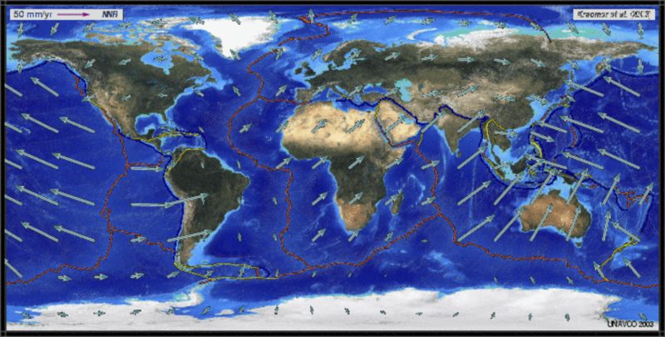
http://cimss.ssec.wisc.edu/sage/geology/lesson2/images/concepts_fig14.gif
Have the students then hypothesize about the past before Pangaea. What positions might the continents be in 50 or 100 million years from today? By working this way, they may be able to deduce the idea of the supercontinent cycle.
Website with plate velocities:
http://hypertextbook.com/facts/ZhenHuang.shtml

Differentiated Instruction:
Idea 1: This one is challenging! Have students use a physiographic map of the Earth to identify plate boundaries using the various features that form along plate boundaries: mid-ocean ridges and rises, deep ocean trenches, coastal volcanic mountain ranges and crumpled and folded mountains. Use one color to mark mid-oceanic ridges and rises as divergent plate boundaries. Use a second color to mark deep ocean trenches, coastal volcanic mountain ranges and crumpled and folded mountains as convergent plate boundaries. Then have students label each plate and shade each outlined plate a different color.
Three Crucial Points:
- 1) The Earth’s surface is covered by a dozen major and several minor plates, which are made of the lithosphere.
- 2) There are three types of plate boundaries: divergent –where plates move apart, convergent – where plates come together and transform – where plates slide past each other.
- 3) As the plates move as a result of convection within the mantle, different landforms are created , and earthquakes and volcanism occur.
Competency for Average Learners: The three types of plate tectonic boundaries are divergent –where plates move apart, convergent – where plates come together and transform – where plates slide past each other. At divergent plate boundaries, mid-oceanic ridges and rises and rift valleys are created, along with new oceanic crust. There are three ways that plates can collide at convergent plate boundaries. Whenever oceanic crust is present, a subduction zone is formed.
When oceanic crust collides with continental crust, the oceanic crust is subducted (forced into the mantle) which produces earthquakes, a deep ocean trench and continental arc volcanism. When oceanic crust collides with oceanic crust, the subduction of the oceanic plate again produces earthquakes, and a deep ocean trench. Melting of the subducting oceanic crust produces island arc volcanism here. When continental crust and continental crust collides, neither plate is subducted, so the edges of each plate crumple and fold creating mountain ranges. At a transform boundary as plates move past each other, earthquakes are created. Plate motion is driven by convection within the mantle.
Gifted Students: Students should be able to describe the types of plate tectonic boundaries, relative plate motions, the landforms and geologic events produced by each and the mechanism of plate tectonics. Students should be able to relate mantle convection to each type of plate boundary and describe the sequence that forms and breaks apart supercontinents. Students should also be able to describe hot spots and their usefulness in determining plate motions.

Common Misconceptions:
Detecting Plate Movement
As students think about processes in Earth science, they may come to realize that many processes are visible and measurable such as hurricanes, earthquakes, and landslides. This may lead some students to assume that plate movement can be observed. Emphasize to students that Earth’s tectonic plates move a few centimeters every year. The movements of the plates that they discuss in this chapter have occurred over the period of millions of years.

Enrichment:
Enrichment Activity 1: Discussion
Go back to chapter 1 to review these concepts: hypothesis, data, facts, theory and law. Why is the plate tectonics idea a theory and not a hypothesis or a law? What portions of the plate tectonic idea are facts and what is the theory? Is continental drift a hypothesis or a theory and why?
Enrichment Activity 2: Discussion
Plate tectonics is often called the “unifying theory of geology.” Why is it called this? How does it explain the distribution of volcanoes, earthquakes, mountain ranges and mineral deposits?

Review Questions:
- What is a plate? How are they identified?
- How do convection cells drive the plates around Earth’s surface?
- What are the three types of plate boundaries?
Points to Consider:
- On the map in Figure 3 above, the arrows show the directions that the plates are going. The Atlantic has a mid-ocean ridge, where seafloor spreading is taking place. The Pacific ocean has many deep sea trenches, where subduction is taking place. What is the future of the Atlantic plate? What is the future of the Pacific plate?
- Using your hands and words, explain to someone how plate tectonics works. Be sure you describe how continents drift and how seafloor spreading provides a mechanism for continental movement.
- Now that you know about plate tectonics, where do you think would be a safe place to live if you wanted to avoid volcanic eruptions and earthquakes?
Homework:
Have students complete the practice section of each concept addressed in this lesson.
Additional Resources:
Understanding Plate Motions, USGS http://pubs.usgs.gov/gip/dynamic/understanding.html#anchor4844282 2012
Intro to Plate Tectonics, PBS http://www.pbs.org/wgbh/aso/tryit/tectonics/intro.html 1998

