Gravity in the Solar System PostRead

Objective
To stress understanding of a concept by summarizing the main idea and applying that understanding to create visual aids and generate questions and comments using a Concept Matrix.

Instruction
Have individuals, pairs, groups, or the class complete the four-box matrix to draw a picture and summarize the main idea, to create a possible test question, and to write either a formula or describe a real-world application.

Activity
Use the four-box matrix to summarize the concept. Follow each box heading to demonstrate your understanding of the content. For the picture you may draw an image or download one from the Internet.
Share your understanding and/or questions through whole class discussions or chat using a chosen chat room.
Concept Name
Universal Law of Gravitation
Summary  Universal Law of Gravitation | Picture  Draw a picture that represents this word.
Test question or formula  Write a test question and answer, or write a scientific or mathematical formula. | Question or application  Ask a question or describe how this applies to real life.

Suggested alternative:
Frayer Model

Possible Answer
Below is the answer key for this activity.

Concept Name
Universal Law of Gravitation
Summary  Newton developed the Universal Law of Gravitation, which recognizes the gravitational attraction between objects.  All objects have a force of attraction between them that is proportional to their mass and distance from each other.  Gravity keeps the planets orbiting the Sun because they are very large, just as gravity keeps satellites orbiting the planets. | Picture  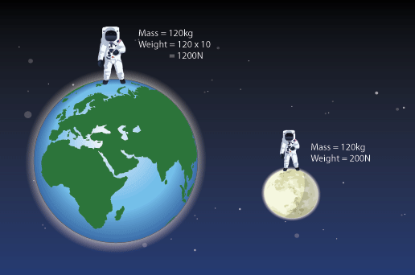
Test question or formula  What does force of gravity depend on?  The force of gravity exists between all objects in the universe; the strength of the force depends on the mass of the objects and the distance between them. | Question or application  What effect does Moons gravity have on Earth?  Moons gravity affects the water in the ocean and causes tides.

