Correlation and Causation
Discussion Questions
These sample discussion questions were submitted by students. They can be used as part of a class discussion, as an essay topic, or as a student project idea.
- Can you prove or disprove causation? How might you go about doing this? – submitted by Audrey Flower
- Look at the chart on http://en.wikipedia.org/wiki/File:PiratesVsTemp%28en%29.svg (duplicated below). This chart shows a data table of global temperature on one axis and number of worldwide pirates in the other. Does this linear correlation support the conclusion that the solution to global warming is by simply having more pirates in the world? – submitted by Antonio Lopez (image created by Mikhail Ryazanov)
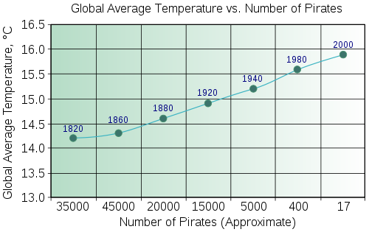
- Find a problem in real life. What are some factors that cause this problem? Can you think of any factors that people might assume to be causation when they are actually just correlation? – submitted by Audrey Flower
- Why is it key to be able to identify the difference between correlation and causation? How might people mislabel correlation for causation in arguments? – submitted by Audrey Flower

