The Birth of an Ocean?
Concept(s):
Earth’s Tectonic Plates (SCI.ESC.341.L.1)
Divergent Plate Boundaries (SCI.ESC.342.2.L.1)
Plate Tectonics through Earth History (SCI.ESC.340.L.1)
Volcanoes at Plate Boundaries (SCI.ESC.371.1.L.1)
Idea/RWA/Topic:
East African Rift Valley
Student centered:
Watch the following trailer for Ice Age 4:
http://www.youtube.com/watch?v=cb9e35tyCE4
While we know that the continents did not separate because of Scrat and his acorn, scientists continue to learn more about how the plates are moving at these cracks, also known as plate boundaries.
A current area of study, the East African Rift Valley, allows scientists to see the action taking place at a developing divergent plate boundary on land rather than underwater at a mid-ocean ridge. The African plate is dividing into two plates and the rift valley being created in the process is referred to as the East African Rift Valley.
Here are images from 2005-2006 when seismic activity picked up:
http://homepages.see.leeds.ac.uk/~eartjw/dabbahu/photos.html
The current thinking in the scientific community is that over time this area will continue to separate until a new ocean develops. Here is an article put out by the University of Rochester:
http://www.rochester.edu/news/show.php?id=3486
What do you think? Are we watching the birth of a new ocean?

Extension Investigations:
- The image below was taken by a NASA astronaut on the International Space Station in January 2012 of the East African Rift Valley:
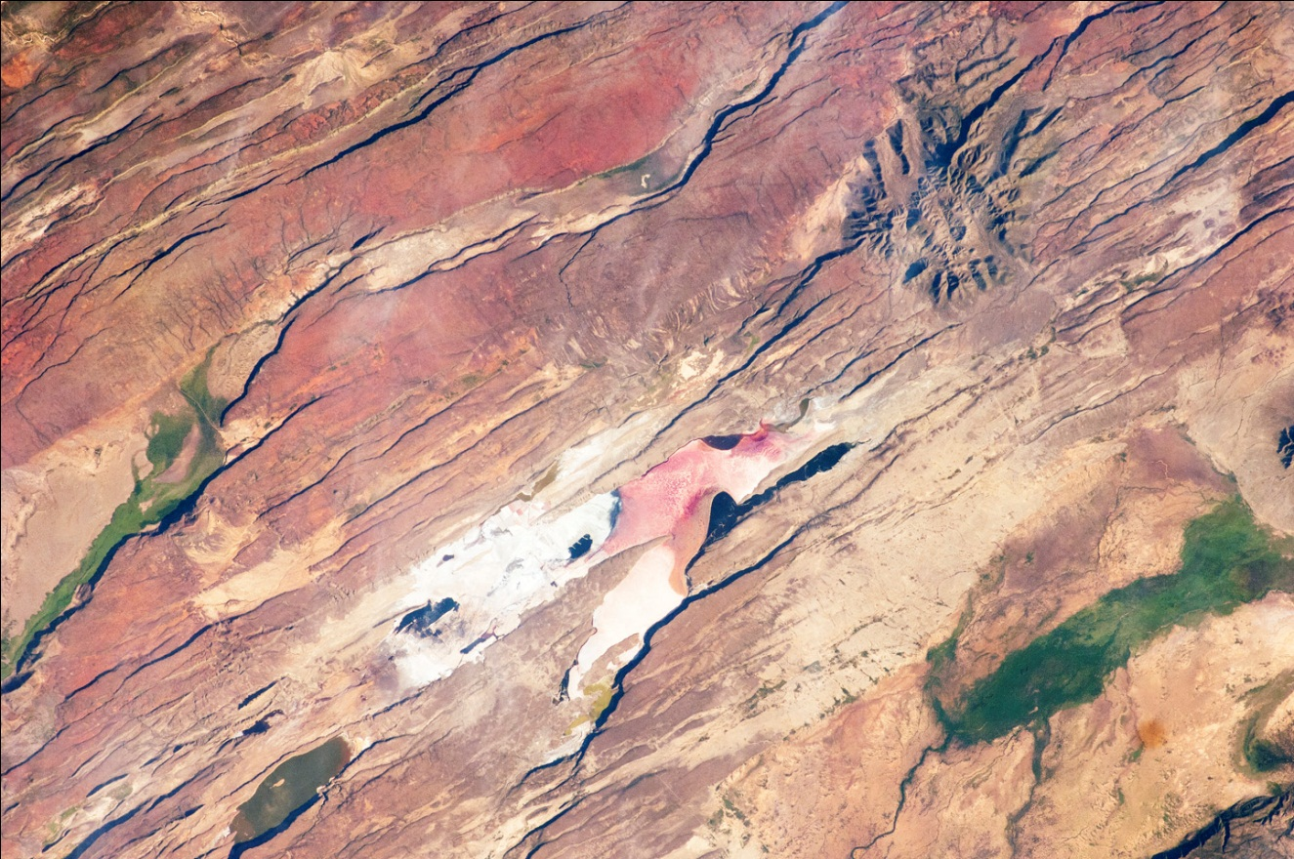
http://earthobservatory.nasa.gov/IOTD/view.php?id=77566

Clearly a lot has changed over the past 6 years. What do you notice? Click on the Earth Observatory link in the picture’s caption to see what scientists have identified in this image.
What evidence does this image provide for tectonic movement? What evidence supports the potential for a future ocean in this location?
- Additionally, scientists have observed volcanic activity associated with the Red Sea near the East African Rift Valley. Here are two images of the same location in the Red Sea taken in 2007 and in 2011: http://earthobservatory.nasa.gov/IOTD/view.php?id=76801
What is different about the two images? How could these differences be attributed to tectonic activity, specifically a divergent plate boundary? Are there other explanations that could describe these differences?
- Thinking back to Pangaea and Gondwana (http://www.exploratorium.edu/origins/antarctica/ideas/gondwana2.html), we know that supercontinents have been present in the past and that our present continental configuration is not static. Using your understanding of what is occurring at the East African Rift Valley, predict where you think the continents will be in the future. Develop a model of how the plates will move due to continued separation of the African plate and the creation of a new ocean.

Resources Cited:
Ice Age 4. YouTube. http://www.youtube.com/watch?v=cb9e35tyCE4
Tim Wright. University of Leeds. http://homepages.see.leeds.ac.uk/~eartjw/dabbahu/photos.html
Exploratorium. http://www.exploratorium.edu/origins/antarctica/ideas/gondwana2.html
Earth Observatory. NASA. http://earthobservatory.nasa.gov/IOTD/view.php?id=76801
http://earthobservatory.nasa.gov/IOTD/view.php?id=77566
University of Rochester. http://www.rochester.edu/news/show.php?id=3486

Connections to Subject Areas/CK-12:
Earth Science
Continental Drift (SCI.ESC.320.L.1)
Seafloor Spreading Hypothesis (SCI.ESC.338.L.1)
Transform Plate Boundaries (SCI.ESC.342.3.L.1)

