Gravity in the Solar System PreRead

Objective
To emphasize students’ understanding of key words and practice applying the definitions of the vocabulary words to examples and drawings using the Frayer Model.

Instruction
For each key vocabulary word in the text, have students complete the four parts of the matrix, labeled “Definition,” “Drawing,” “Example,” and “Non-example.”

Activity
Fill in each box of the graphic organizer below. Complete all boxes for each key vocabulary word from the text.
Definition  What does this word mean in your own words?  Gravity | Drawing  Draw a picture that represents this word.
Example  Give an example or use this word in a complete sentence. | Non-Example  Give a counter example or comment.

Suggested Alternative:
Concept matrix

Possible Answer
Below is the answer key for this activity.

Definition  Newton defined the Universal Law of Gravitation, which states that a force of attraction, called gravity, exists between all objects in the universe  Gravity | Drawing  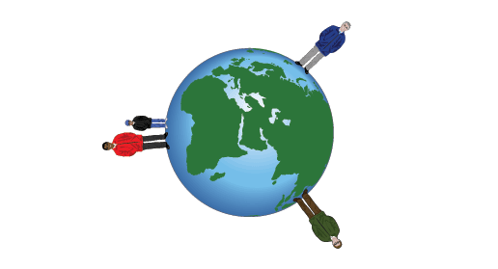
Example  Gravity is the force that causes objects to fall to the ground and also the force that keeps the Moon circling Earth instead of flying off into space in a straight line. Gravity keeps each planet orbiting the Sun because the star and its planets are very large objects. | Non-Example  My boats speed comes not from gravity but from  the wind that fills my bright parasail.

